23CSE111
OBJECT ORIENTED PROGRAMMING
LAB REPORT



Department computer science and engineering
Amrita school of computing
Amrita vishwa vidyapeetham, Amaravati campus

Name: K. Divya teja
Verified by Class/section : CSE – B
Roll no:av.sc.u4cse24138

INDEX
S no | Title | Page no | Date | Signature
 | WEEK -1
1 | Explain the process of download & Installation of JDK | 4
2 | Write a program to print Student’s name, Roll no, Section | 7
 | WEEK-2
1 | Write a simple java program to calculate factorial of a number | 9
2 | Write a simple java program to find the simple interest by taking iinputs from the user | 10
3 | Write a program to calculate the Fibonacci sequence and take the input from the user | 13
4 | Write a program to find the area of triangle using hereon’s formula  . | 15
5 | Write a program to convert temperature from celssius to fahrenheit | 17
 | WEEK-3

WEEK-1
1) AIM:
The process of download & installation of JDK(java development kit)
Download the JDK:
- Visit the official Oracle website and click on JDK 21 version and select our operating system type of your Desktop .
- Click the link to download file description /product.
Install JDK:
1. Once downloaded, run the installer.
2. Follow the instructions and keep clicking "Next" until it's done.
Set Environment Variables (Windows):
1. Open the Start Menu and search for "Environment Variables".
2. Click "Edit the system environment variables".
3. In the System Properties window, click "Environment Variables".
4. Under "System variables," Double click the path variable click the "New" and Add the bin directory of your JDK (C:\Program Files\Java\jdk-21\bin) to the path.

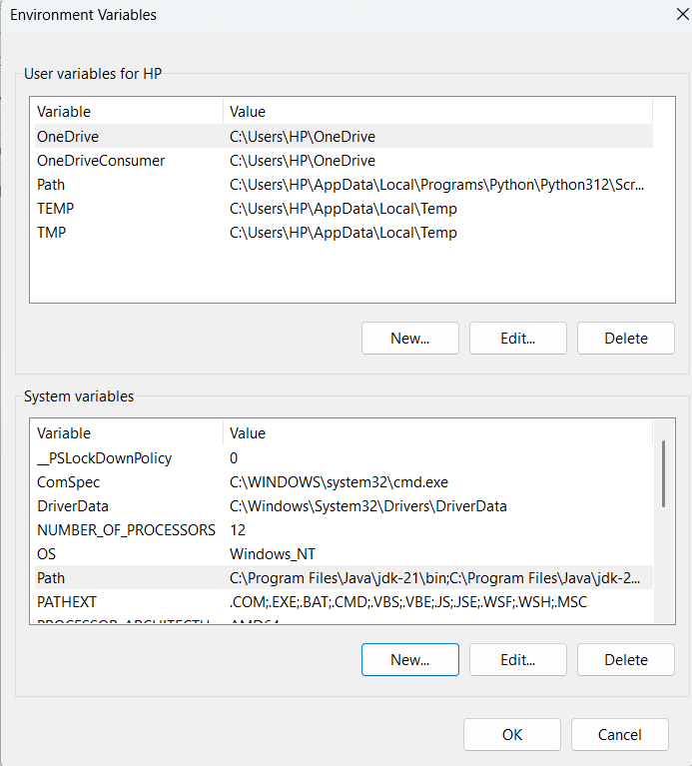

Checking the JDK version:

- Open the start menu and search command prompt open it.
- To check the java version
Type java –version and click enter (or)
Type javac –version and click enter to check the version
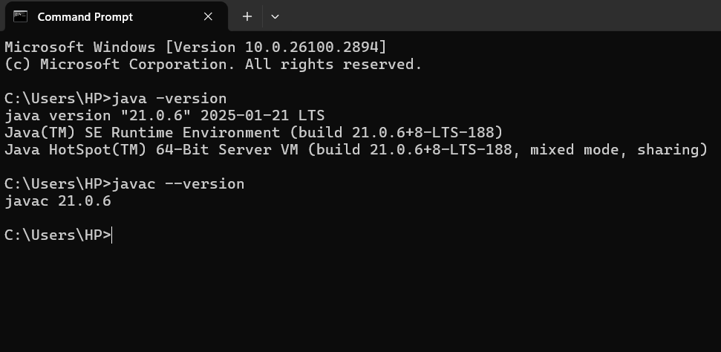

2) AIM: Write a program to print Student’s name, Roll no and Section.
Write our program in notepad and execute in Command prompt
Program:
class Demo
{
public static void main(String[] args)
{
System.out.println("NAME:k.Divya teja");
System.out.println("ROLL NO:av.sc.u4cse24148");
System.out.println("Section: CSE-B");
}
}
OUTPUT:
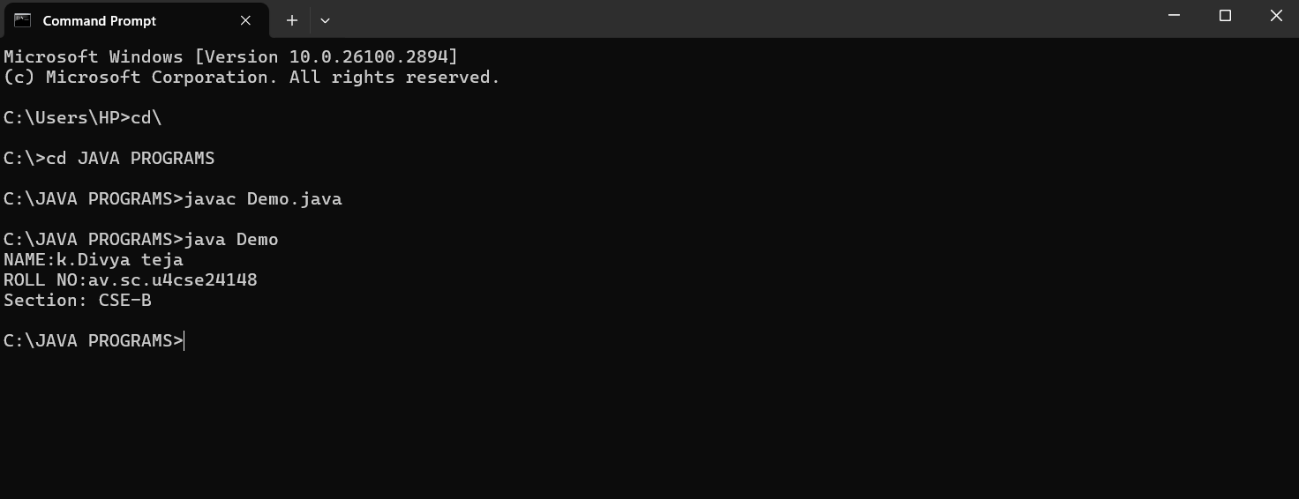
ERRORS:
S.No | Error | Error rectification
1 | path error | Using correct path and  Absence of ‘-‘ symbol
2 | Syntax error | Use Captial S in System.out.println()

WEEK-2
1) AIM:
Write a simple program to calculate factorial of a number and read the input from user

PROGRAM :
class Test {
static int factorial(int n)
{
int res = 1, i;
for (i = 2; i <= n; i++)
res *= i;
return res;
}
public static void main(String[] args)
{
int num = 5;
System.out.println("Factorial of " + num + " is "
+ factorial(5));
}
}
OUTPUT :
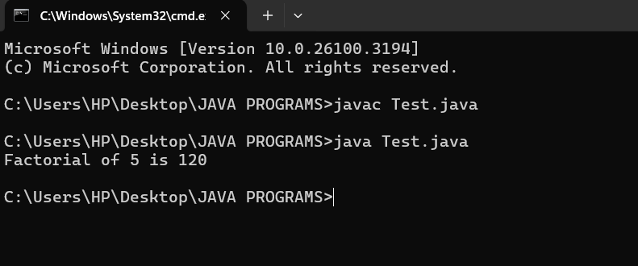

S.No | Error type | Reason for error | Rectification
1 | Undeclared variable error | Missing variable | Variable declared
2 | Missing import statement | Not importing packages | Packages imported
3 | Logical error | Wrong formula | Formula rectified

2) AIM : Simple Java Program for finding simple interest by taking input from
PROGRAM :
import java.util.Scanner;
class simple {
public static void main(String[] args) {
Scanner input = new Scanner(System.in);

System.out.print("Enter p :");
int p = input.nextInt();
System.out.print("Enter t :");
int t = input.nextInt();
System.out.print("Enter r :");
int r = input.nextInt();

System.out.println("The amount is:" + (p*t*r)/100);

}
}

OUTPUT :
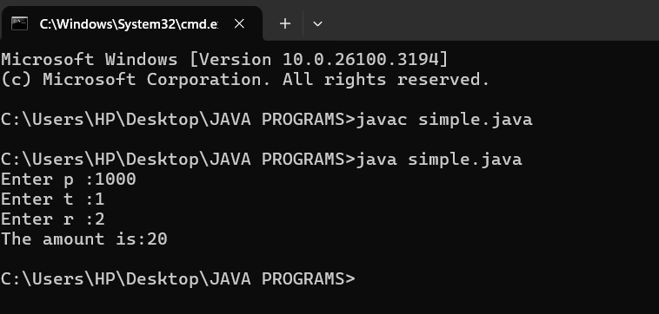
ERROR :
S.No | Error type | Reason for error | rectification
1 | Runtime error | Incorrect path | Copied correct path
2 | Syntax error | { missing | { added
3 | Logical error | Wrong formula | Formula rectified

3) AIM : Write a program to to calculate the fibonacii sequence and take the input from user
PROGRAM :
import java.util.*;
class fibo
{
public static void main(String args[])
{
Scanner sc = new Scanner(System.in);
int num;
int f3;
int f1 = 0;
int f2 = 1;
int i = 2;

System.out.print("Enter a number:");
num = sc.nextInt();
System.out.println(f1);
System.out.println(f2);

while(i<num)
{
f3 = f1+f2;
f1 = f2;
f2 = f3;
System.out.println(f3);
i = i+1;
}
}
}
OUTPUT :
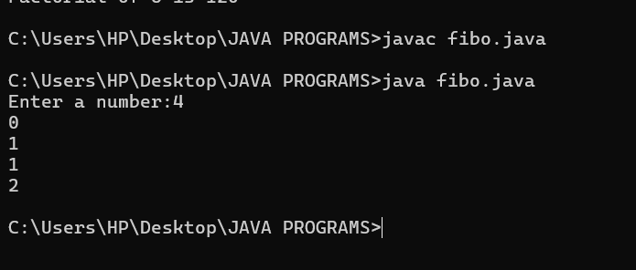
ERROR :
S.No | Error type | Reason for error | Rectification
1 | Logical error | Incorrect formula | Formula rectified
2 | Run-time error | Incorrect path | Added correct path

4) AIM : Write a java program to find area of triangle using heron’s formula and area of triangle
PROGRAM :
import java.util.Scanner;
class Area {

public static void main(String args[]) {
Scanner input= new Scanner(System.in);

System.out.print("Enter the length of side a: ");
double a = input.nextDouble();

System.out.print("Enter the length of side b: ");
double b = input.nextDouble();

System.out.print("Enter the length of side c: ");
double c = input.nextDouble();

double s = (a + b + c) / 2;

double area = Math.sqrt(s * (s - a) * (s - b) * (s - c));

System.out.println("The permeter of triangle is:" + s);
System.out.printf("The area of the triangle is:" + area);
}
}
OUTPUT :
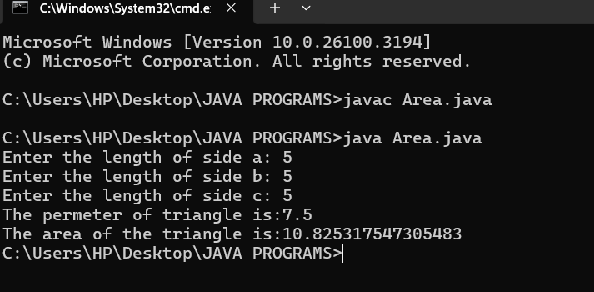
ERRORS :
S no | Error type | Reason for error | Rectification
1 | Syntax error | Semicolon missing | Semi colon added
2 | Missing Scanner | Creating scanner input | Scanner added

5) AIM : Write a java program to convert temperature from Celsius to Fahrenheit
PROGRAM :
class celsiustofahrenheit {
public static void main(String[] args)
{
double celsius = 10.0, fahrenheit = 0.0;
fahrenheit = (celsius * 1.8) + 32;
System.out.println(
" value of temperature in fahrenheit:"
+ fahrenheit);
}
}
OUTPUT :
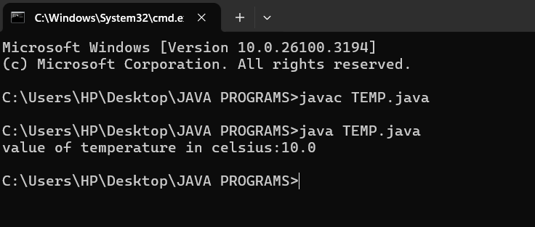
ERRORS :
S.No | Error type | Reason for error | Rectification
1 | Runtime error | Incorrect path selection | Correct path added
2 | Logical error | Incorrect logic | Correct logic

WEEK-3
- AIM :
Write a java program with following instructions
- Create a class with name car
- Create four attributes named, car colour, car brand , fuel type , mileage.
- Create 3 methods named start , stop, service .
- Create 3 objects named c1,c2,c3
- Create a constructor with parameters , car colour , car brand , fuel type and mileage.
PROGRAM :
class car {

//ATTRIBUTES
String car_brand;
String car_colour;
String fuel_type;
int mileage;

//CONSTRUCTORS
public car(String car_brand,String car_colour,String fuel_type,int mileage){
this.car_brand = car_brand;
this.car_colour = car_colour;
this.fuel_type = fuel_type;
this.mileage = mileage;
}

//METHODS
public void start() {
System.out.println("CAR IS STARTED");
}
public void stop() {
System.out.println("CAR IS STOPPED");
}
public void service() {
System.out.println("CAR IS I SERVICE");
}
public void car_details() {
System.out.println("CAR BRAND IS :" + car_brand);
System.out.println("CAR COLOUR IS :" + car_colour);
System.out.println("CAR FUEL TYPE IS :" + fuel_type);
System.out.println("CAR MILEAGE IS :" + mileage);
}

//MAIN PROGRAM
public static void main(String[] args) {
// CREATING OBJECTS FOR CLASS CAR
car c1 = new car("MCLAREN","GREEN","PETROL",12);
car c2 = new car("FERRARI","RED","PETROL",18);
car c3 = new car("LAMBORGHINI","ORANGE","PETROL",20);
//CALLING METHODS
c1.car_details();
System.out.println(" ");
c2.car_details();
System.out.println(" ");
c3.car_details();
}
}class car {

//ATTRIBUTES
String car_brand;
String car_colour;
String fuel_type;
int mileage;

//CONSTRUCTORS
public car(String car_brand,String car_colour,String fuel_type,int mileage){
this.car_brand = car_brand;
this.car_colour = car_colour;
this.fuel_type = fuel_type;
this.mileage = mileage;
}

//METHODS
public void start() {
System.out.println("CAR IS STARTED");
}
public void stop() {
System.out.println("CAR IS STOPPED");
}
public void service() {
System.out.println("CAR IS I SERVICE");
}
public void car_details() {
System.out.println("CAR BRAND IS :" + car_brand);
System.out.println("CAR COLOUR IS :" + car_colour);
System.out.println("CAR FUEL TYPE IS :" + fuel_type);
System.out.println("CAR MILEAGE IS :" + mileage);
}

//MAIN PROGRAM
public static void main(String[] args) {
// CREATING OBJECTS FOR CLASS CAR
car c1 = new car("MCLAREN","GREEN","PETROL",12);
car c2 = new car("FERRARI","RED","PETROL",18);
car c3 = new car("LAMBORGHINI","ORANGE","PETROL",20);
//CALLING METHODS
c1.car_details();
System.out.println(" ");
c2.car_details();
System.out.println(" ");
c3.car_details();
}
}
CLASS DIAGRAM :
CAR
car_brand : String
car_colour : String
fuel_type : String
mileage : int
+ car (String, String, String,int)
+start() : void
+stop() : void
+service : void
+ car_details : void

OUTPUT :
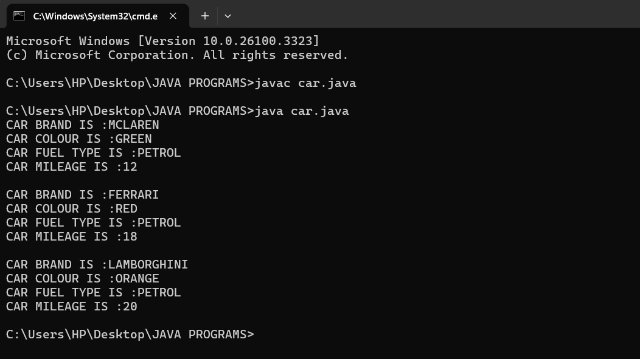
ERROR :
S.No | Error type | Reason for error | Rectification
1 | Runtime error | Incorrect symbol in main program | { symbol is added
2 | Logical error | Incorrect logic | Correct logic

4) AIM :
create a class named bankaccount with method deposit and with draw where the deposit method should accepts a parameter and when this method is called the deposited amount should be current balance .In addition to that when a withdraw method is called it has to verify whether withdraw amount is less than the current balance .If not display a message saying insufficient funds.Use the constructer to display the details of the customer (Customer name,account number , IFSC,branch) .Also create two customer objects c1,c2
PROGRAM :
class bank_account {
String name ;
String number;
String IFSC;
String branch;
int balance;
int amount;
//CONSTRUCTORS
public bank_account(String name, String number, String IFSC, String branch, int balance,int amount){
this.name = name;
this.number = number;
this.IFSC = IFSC;
this.branch = branch;
this.balance = balance;
this.amount = amount;
}
//METHODS
public void details() {
System.out.println("Customer Name: " + name);
System.out.println("Account Number: " + number);
System.out.println("IFSC Code: " + IFSC);
System.out.println("Branch: " + branch);
System.out.println("Current Balance: " + balance);
}

public void deposit(){
if (amount >= 0) {
System.out.println("DEPOSITED AMOUNT IS : " + amount);
} else {
System.out.println("INVALID DEPOSIT AMOUNT");
}
}

public void withdraw() {
if (amount >=0 && amount <= balance ) {
System.out.println("WITHDRAW AMOUNT IS: " + amount);
} else if ( amount > balance) {
System.out.println("INSUFFICINET FUNDS");
} else {
System.out.println("INVALID WITHDRAW AMOUNT");
}
}

//MAIN PROGRAM
public static void main(String[] args) {
//CREATING OBJECTS
bank_account c1 = new bank_account("TEJA","12346789","SBI1997","GUNTUR",10000,500);
bank_account c2 = new bank_account("RISHI","987654123","SBI1996","GUNTUR",15000,800);
//CALLING METHODS
c1.details();
System.out.println(" ");
c1.deposit();
System.out.println(" ");
c1.withdraw();
System.out.println(" ");
c2.details();
System.out.println(" ");
c2.deposit();
System.out.println(" ");
c2.withdraw();
}
}
CLASS DIAGRAM :
bank_account
name : String
number : String
IFSC : String
branch : String
balance : int
amount: int
+ bank_account(String, String, String, String,int,int)
+ details() : void
+ deposit() : void
+ withdraw : void

OUTPUT :
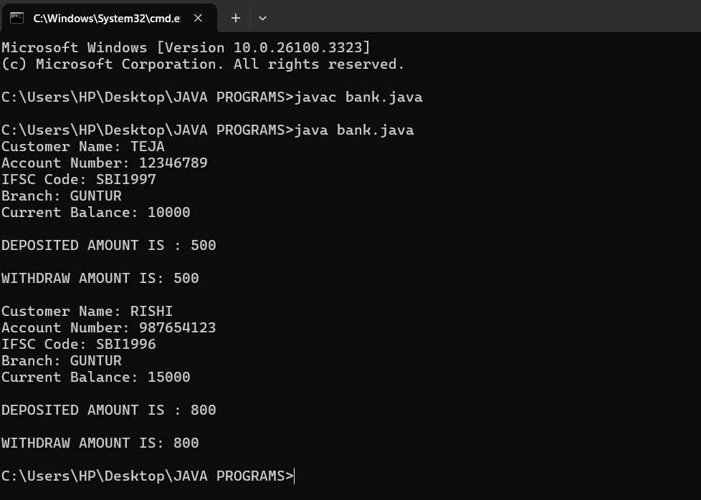

ERROR :
S.No | Error type | Reason for error | Rectification
1 | syntax error | Forgot to keep main word in main program | Main is added
2 | Logical error | Incorrect logic | Correct logic

